# Artificial Intelligence Lab

# Lab1

Code

domains

disease,indication=symbol predicates

symptom(disease,indication) clauses symptom(chicken_pox,high_fever). symptom(chicken_pox,chills).

symptom(flu,chills). symptom(flu,severe_body_ache). symptom(cold,runny_nose). symptom(flu,runny_nose). symptom(flu,moderate_cough).

OUTPUT

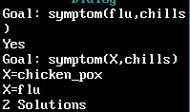

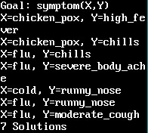

# Lab 2

## CODE

domains person=symbol predicates grandfather(person,person) grandmother(person,person) father(person,person) mother(person,person) male(person) female(person) clauses female(ramsarni). female(krishna). female(geetabali). female(jennifer). female(babita). female(ritu_kapoor). female(nitu). female(reema_kapoor). male(prithviraj_kapoor). male(raj_kapoor). male(shammi_kapoor).

male(shashi). male(randhir_kapoor). male(rajeev_kapoor). male(rajan_nandan). male(rishi_kapoor). male(ranbir_kapoor). male(sanjay). male(saif). grandfather(prithviraj_kapoor,randhir_kapoor). grandfather(prithviraj_kapoor,ritu_kapoor). grandfather(prithviraj_kapoor,rishi_kapoor). grandfather(prithviraj_kapoor,reema_kapoor).

grandfather(raj_kapoor,karishma). grandfather(shammi_kapoor,karishma). grandfather(shashi,karishma). grandfather(raj_kapoor,kareena). grandfather(shammi_kapoor,kareena).

grandfather(shashi,kareena). grandfather(raj_kapoor,ranbir_kapoor). grandfather(shammi_kapoor,ranbir_kapoor).

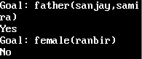grandfather(shashi,ranbir_kapoor). grandmother(ramsarani,randhir_kapoor). grandmother(ramsarani,ritu_kapoor). grandmother(ramsarani,rishi_kapoor). grandmother(ramsarani,reema_kapoor). grandmother(krishna,karishma). grandmother(geetabali,karishma). grandmother(jennifer,karishma). grandmother(krishna,karrena). grandmother(geetabali,karrena). grandmother(jennifer,karrena). grandmother(krishna,ranbir_kapoor). grandmother(geetabali,ranbir_kapoor). grandmother(jennifer,ranbir_kapoor). father(prithviraj_kapoor,raj_kapoor). father(prithviraj_kapoor,shammi_kapoor). father(prithviraj_kapoor,shashi_kapoor). father(randhir_kapoor,karishma). father(randhir_kapoor,kareena). father(rishi_kapoor,ranbir_kapoor).

father(sanjay,samira). father(shammi_kapoor,aditya_raj_kapoor).

mother(ramsarani,raj_kapoor). mother(ramsarani,shammi_kapoor). mother(ramsarani,shashi_kapoor). mother(geetabali,aditya_raj_kapoor). mother(krishna,randhir_kapoor). mother(krishna,rajeev_kapoor). mother(krishna,ritu_kapoor). mother(krishna,rishi_kapoor). mother(krishna,reema_kapoor). mother(karishma,samira). mother(neetu,ranbir_kapoor).

## OUTPUT

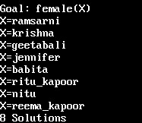

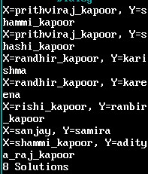

### **Lab 3** CODE

domains person=symbol predicates grandfather(person,person) grandmother(person,person) father(person,person) mother(person,person) male(person) female(person) happy(person) sister(person,person) have2children(person) son(person,person) grandchild(person,person) aunt(person,person)

clauses female(ramsarni). female(karishna). female(kareena). female(geetabali). female(jennifer). female(babita). female(ritu_kapoor). female(nitu). female(reema_kapoor). male(prithviraj_kapoor). male(raj_kapoor). male(shammi_kapoor).

male(shashi). male(randhir_kapoor). male(rajeev_kapoor). male(rajan_nandan). male(rishi_kapoor). male(ranbir_kapoor). male(sanjay). male(saif).

grandfather(prithviraj_kapoor,randhir_kapoor). grandfather(prithviraj_kapoor,ritu_kapoor). grandfather(prithviraj_kapoor,rishi_kapoor). grandfather(prithviraj_kapoor,reema_kapoor).

grandfather(raj_kapoor,karishma). grandfather(shammi_kapoor,karishma). grandfather(shashi,karishma). grandfather(raj_kapoor,kareena). grandfather(shammi_kapoor,kareena).

grandfather(shashi,kareena). grandfather(raj_kapoor,ranbir_kapoor). grandfather(shammi_kapoor,ranbir_kapoor).

grandfather(shashi,ranbir_kapoor).

grandmother(ramsarani,randhir_kapoor). grandmother(ramsarani,ritu_kapoor). grandmother(ramsarani,rishi_kapoor). grandmother(ramsarani,reema_kapoor).

grandmother(krishna,karishma). grandmother(geetabali,karishma). grandmother(jennifer,karishma). grandmother(krishna,karrena). grandmother(geetabali,karrena). grandmother(jennifer,karrena). grandmother(krishna,ranbir_kapoor). grandmother(geetabali,ranbir_kapoor). grandmother(jennifer,ranbir_kapoor).

father(prithviraj_kapoor,raj_kapoor). father(prithviraj_kapoor,shammi_kapoor). father(prithviraj_kapoor,shashi). father(raj_kapoor,randhir_kapoor). father(raj_kapoor,ritu_kapoor). father(raj_kapoor,rishi_kapoor). father(raj_kapoor,reema_kapoor). father(randhir_kapoor,karishma). father(randhir_kapoor,kareena). father(rishi_kapoor,ranbir_kapoor). father(sanjay,samira). father(shammi_kapoor,aditya_raj_kapoor).

mother(ramsarani,raj_kapoor). mother(ramsarani,shammi_kapoor).

mother(ramsarani,shashi). mother(geetabali,aditya_raj_kapoor). mother(krishna,randhir_kapoor). mother(krishna,rajeev_kapoor). mother(krishna,ritu_kapoor). mother(krishna,rishi_kapoor). mother(krishna,reema_kapoor).

mother(karishma,samira). mother(neetu,ranbir_kapoor).

happy(X):-father(X,Y);mother(X,Y),male(X);female(X). sister(X,Y):-father(Z,X),father(Z,Y),female(X),X<>Y. have2children(X):-father(X,Y),father(X,Z),sister(Y,Z),Y<>Z. son(X,Y):-father(Y,X),male(X).

grandchild(X,Y):-father(X,Z),father(Z,Y). aunt(X,Y):-father(Z,Y),sister(X,Z).

### **OUTPUT**

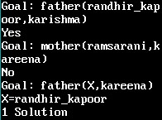

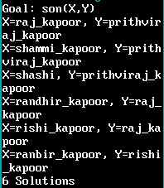



**Lab4**

## To check whether component is a member of a list or not

### CODE

domains

integerlist=integer*

predicates member(integer,integerlist)

clauses member(X,[X|_]). member(X,[_|Tail]):-member(X,Tail).

**OUTPUT**

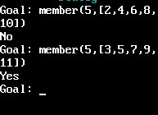

# To combine two Lists

## CODE

domains symbollist=symbol*

predicates conc(integerlist,integerlist,integerlist)

clauses conc([],L,L) conc([X|L1],L2,[X|L3]):-conc(L1,L2,L3)

## OUTPUT

